Full Stack Development with MERN
Project Documentation format

1. Introduction
- Project Title: Flight Finder: Navigating Your Air Travel Options.
- Overview: A full-stack solution designed to streamline the air travel search and booking experience for frequent travellers.
- Team Roles:
- Lead Developer: Shaik Saibhan Ahammed.
  - UI/UX Designer: Nimmakayala Venugopal.
  - Database Admin: M Akash
  - Web Tester: Marati Sindhe Lokesh

2. Project Overview
- Purpose: To eliminate the friction in flight discovery by providing a fast, persistent, and mobile-responsive platform.
- Goals: Achieve sub-3 second search speeds and ensure 100% booking data persistence.
- Key Features: Dynamic city-based search, interactive flight cards, and a personal booking dashboard.

3. Architecture
- Frontend (React): Uses a component-based architecture with React hooks for state management and Bootstrap for a mobile-first responsive layout.
- Backend (Node/Express): A RESTful API that handles JSON-based communication between the user and the database.
- Database (MongoDB): A NoSQL document-oriented database that stores flight schedules and user booking records with flexible schemas.

4. Setup Instructions
- Prerequisites: Install Node.js (v16+), npm, and create a MongoDB Atlas cluster.
- Installation: 1. git clone [repository-URL] 2. npm install in both client and server folders. 3. Create a .env file for the MONGODB_URI. 4. Run npm start to launch.

5. Folder Structure
- Client: Contains /public for assets and /src for React components, pages, and CSS styling.
- Server: Contains /models (Mongoose schemas), /routes (API endpoints), and /config (DB connection).

6. Running the Application
- Development: Use concurrently to run both servers or open two terminals.
- Commands: cd client && npm start and cd server && npm start.
- Access: Open localhost:3000 to view the UI.

7. API Documentation
- GET /Api/flights: Queries the database for flights based on origin/destination.
- POST /Api/bookings: Submits a new booking object to the MongoDB collection.
- GET /Api/seed: Admin-only route to refresh the database with sample flight data.

8. Authentication
- Method: Session-based validation to track the user's booking history.
- Security: Environment variables protect sensitive database credentials and API keys from being exposed in the source code.

9. User Interface (UI)
- Search Page: Features dynamic dropdowns that update based on available routes.
- Results Page: Displays flight details (price, duration, airline) in a card-based layout.
- Dashboard: Shows a list of "My Confirmed Tickets" retrieved from the backend.

10. Testing Strategy
- Unit Testing: Testing individual API routes for correct JSON responses.
- UAT (User Acceptance): Manual testing focused on the user's "Pains" and "Gains" identified in the Empathy Map.
- Performance: Verifying the reliability of the system under simultaneous search requests.
11. Screenshots or Demo
- Live Link: http://localhost:3000/
- Visuals:

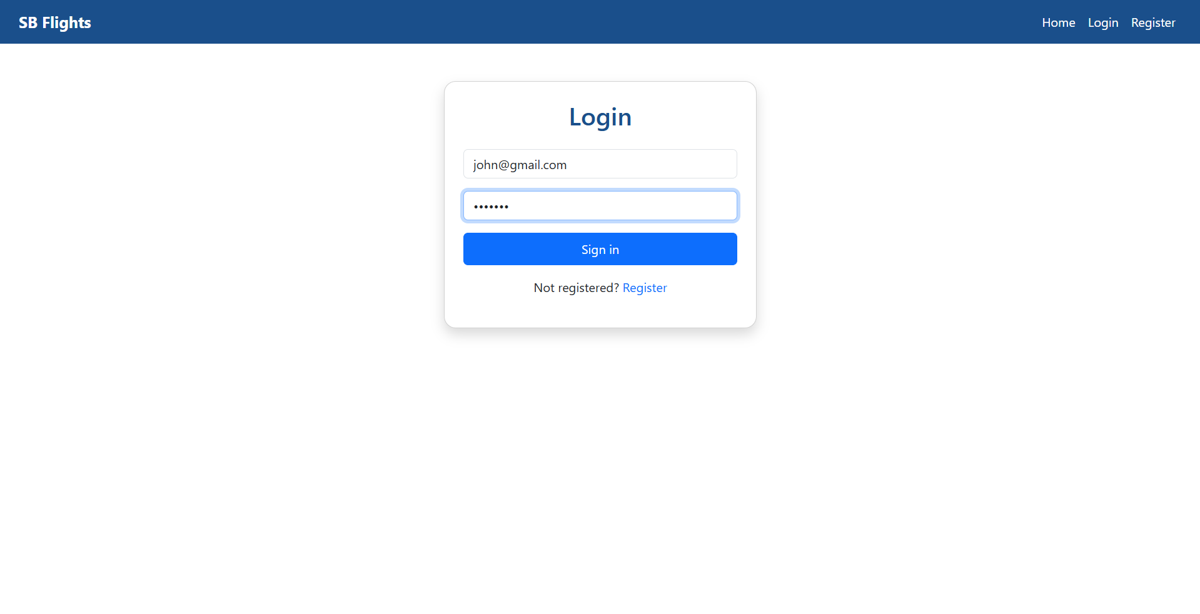

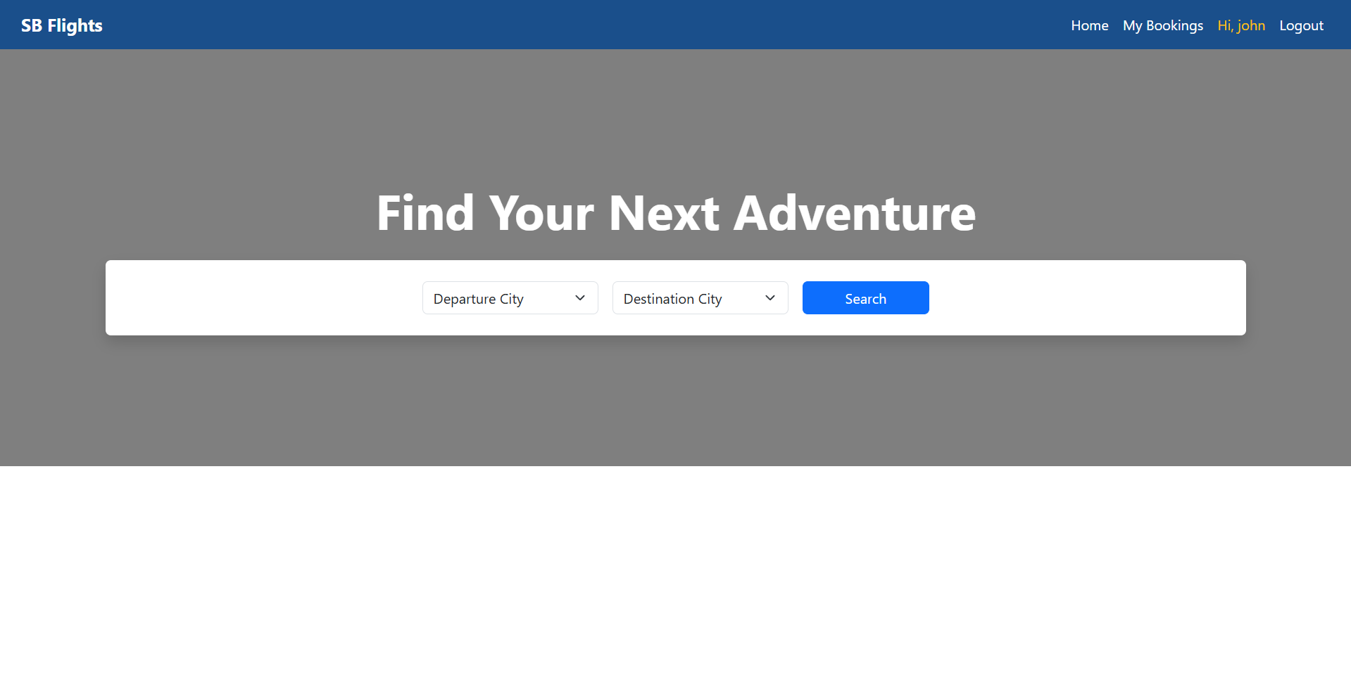
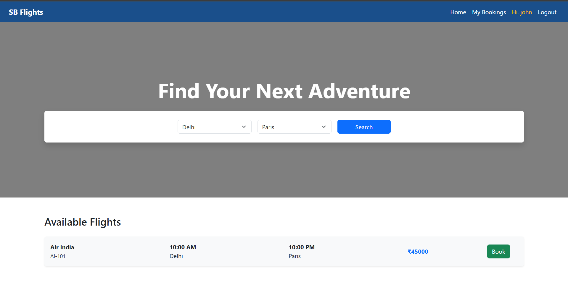

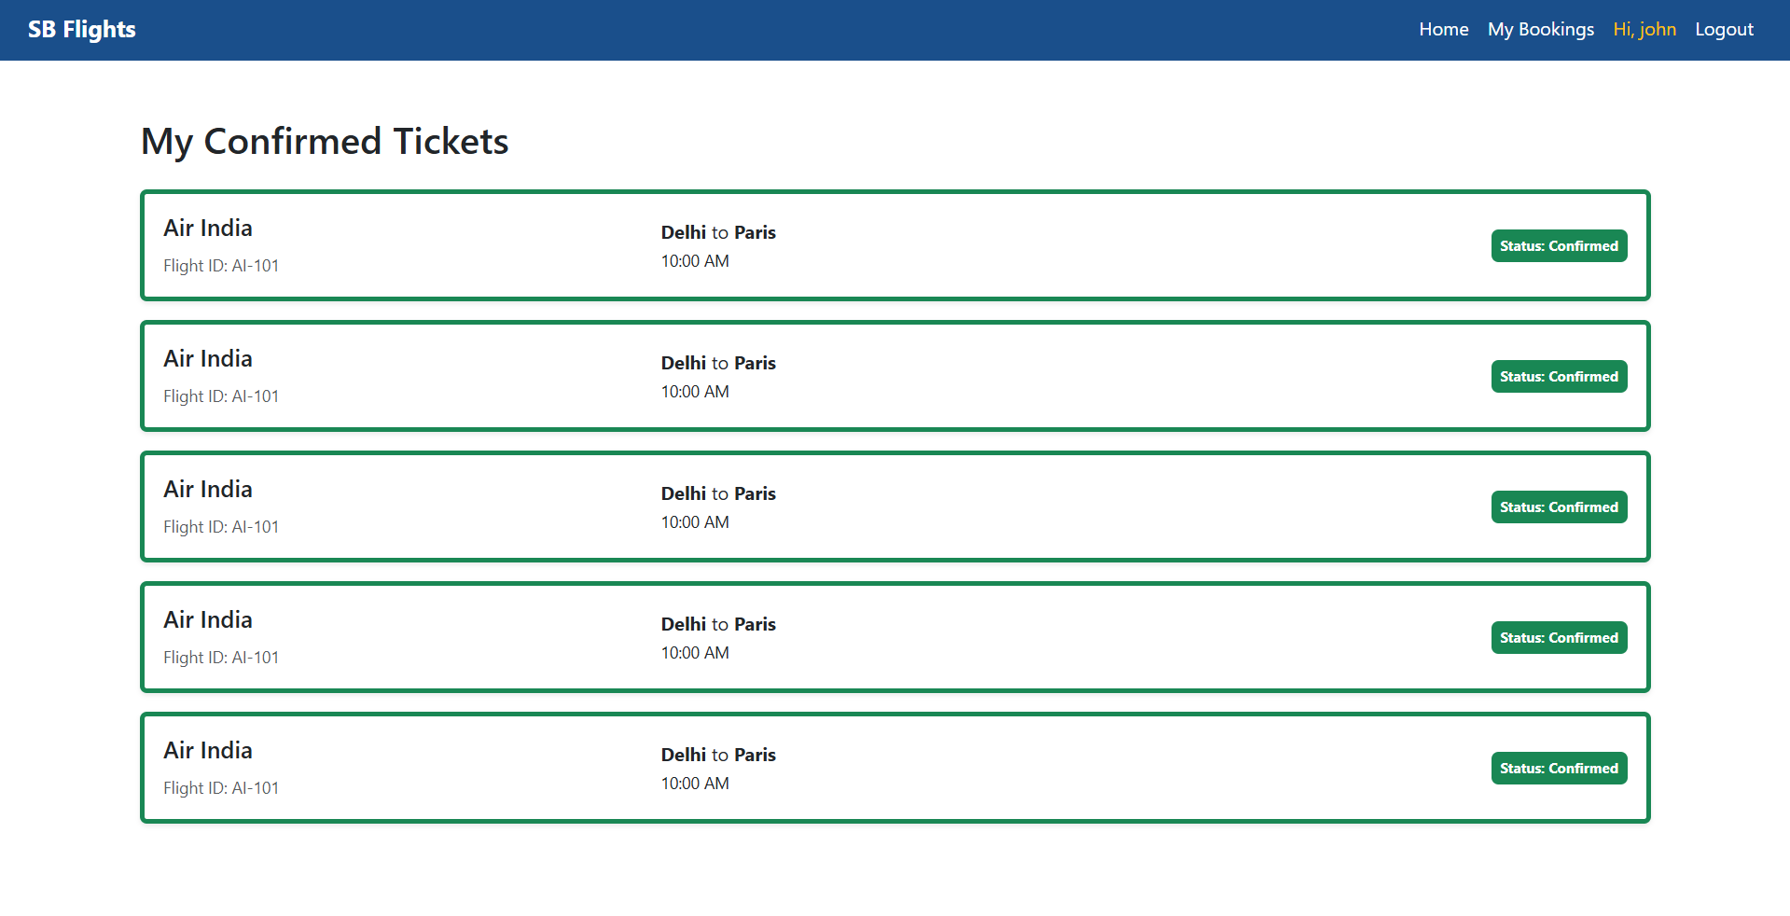

12. Known Issues
- Latency: Occasional delays in fetching results due to free-tier cloud hosting "cold starts."
- Validation: Minimal input validation for special characters in the search bar.

13. Future Enhancements
- Live API: Integration with real-world aviation APIs for live prices.
- Payments: Adding a checkout flow using Stripe or Razor pay.
- Notifications: Automatic email confirmation for every booked ticket.

14. Problem-Solution Fit
- The Fit: The MERN architecture directly solves the "Slow UI" pain point by using React's virtual DOM and Node's non-blocking I/O.
- Outcome: Users feel confident and in control when their booking data persists across sessions.

15. Conclusion & Sign-off
- Final Result: The project successfully bridges the gap between traveller needs and modern web technology.
- Status: Ready for deployment to production after final UAT approval.
the project.

